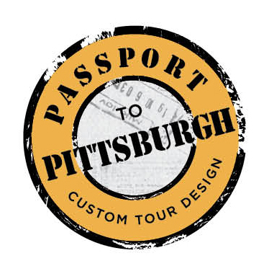
Passport to Pittsburgh, LLC presents
The “Pittsburgh 101 “Tour

Tepper School of Business Saturday October 15, 2016 9:30-12:30

Join in the fun of this “crash course” on the city of Pittsburgh!
We will visit landmarks, attractions and neighborhoods to learn and experience the “burgh” on this whirlwind tour of the “city of bridges”.

9:30 Am- Pick up CMU Campus: Tepper School of Business –
(Corner of Tech Street and Margaret Morrison)
10:00 am- Duquesne Incline ride and tour duq.incline@duquesneincline.org
This iconic Pittsburgh historic landmark opened its doors to passengers in 1877 and is still operating using the same hoisting system today. We will ride the “funicular” up the side of Mt. Washington and enjoy the view.
10:30- North Shore- Hometown Heroes!! A short ride/stroll along the north shore of Pittsburgh will give guests a different perspective on the city and highlight some of Pittsburgh’s most well- known hometown heroes.
11:15- Pittsburgh Strip District- A crash course of Pittsburgh would not be complete without a visit to the “foodie” mecca of the city and a tasting at the original Primanti Brothers Sandwich Shop. www.primantibros.com
11:45- Market Square- Our last stop is Pittsburgh’s “piazza”: Market Square. This centrally located pedestrian only square has become the “heart” of downtown. WE will explore and taste our way around the square.
12:30pm- Return to CMU

Questions: Kim Adley, Owner and Custom Tour Designer
412-298-0409 passport2pgh@gmail.com
www.passporttopittsburgh.com

